**CS 2102: Group Project**

# **Group 57 – Restaurant Reservation**

# **Group Members:**

## Oliver Zheng

## Adrianna Fu

## Lua Jun Kai Edenuis

**Project Responsibilities**

|  |  |
| --- | --- |
| Oliver Zheng | Developed majority of the web-application, helped design the ER Diagram, wrote some minor queries. |
| Lua Jun Kai Edenuis | Wrote triggers, helped design the ER diagram, implemented reservation in the web app. |
| Adrianna Fu | Wrote interesting queries, helped design the ER diagram, implemented incentives in the web app. |

**Project Description**

Our web application allows two types of users to use restaurant reservation system: customers, who can make reservations at and leave reviews for restaurants, and owners, who manage restaurant branch pages and respond to reviews.

All users can:

* Create an account with a unique email address

Customers can:

* Search up restaurants by name
* Make reservations at a restaurant branch for a certain time and date in the future for a set number of guests
* Leave reviews for restaurants they have visited
* Earn points for making reservations
* Use points to redeem rewards

Owners can:

* Respond to reviews from customers
* See reservations

**ER Model**

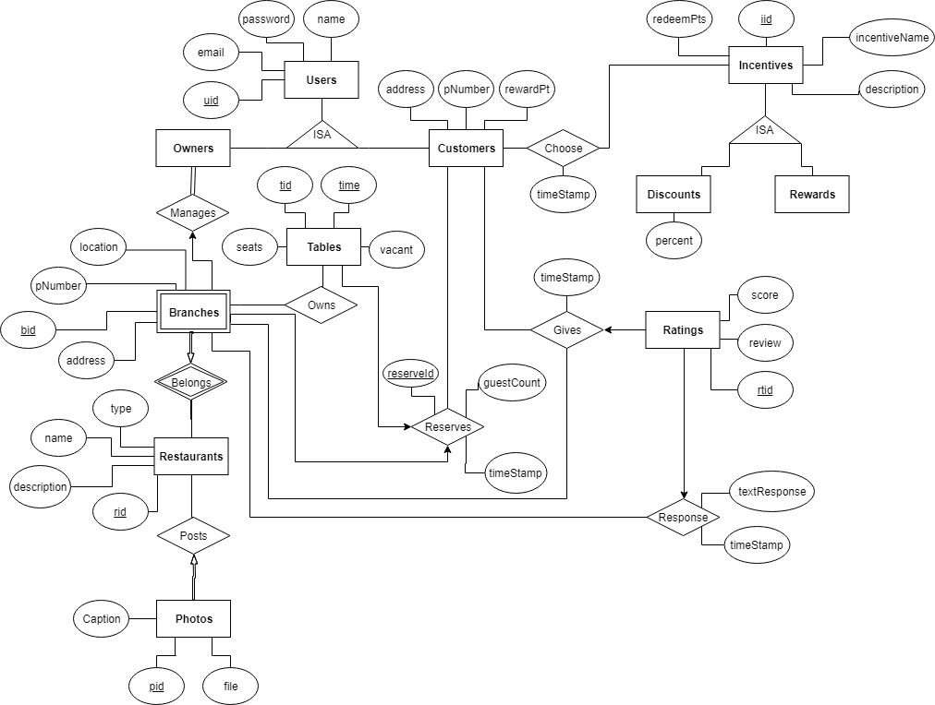

**Relational Schema**

create table Users (

uid SERIAL,

name VARCHAR(50) NOT NULL,

email VARCHAR(50) UNIQUE,

password VARCHAR(50) NOT NULL,

primary key (uid)

);

create table Customers (

uid INT NOT NULL,

address VARCHAR(50),

pNumber CHAR(8) NOT NULL UNIQUE,

rewardPt INT DEFAULT 0 CHECK (rewardPt >= 0),

foreign key (uid) references Users(uid) on delete cascade

);

create table Restaurants (

rid SERIAL,

name TEXT NOT NULL UNIQUE,

type TEXT,

description TEXT,

primary key (rid)

);

create table Branches (

rid INT NOT NULL,

bid INT NOT NULL,

pNumber CHAR(8) UNIQUE,

address VARCHAR(100) NOT NULL,

location TEXT,

primary key (bid, rid),

foreign key (rid) references Restaurants (rid) on delete cascade

);

create table Owners (

uid INT,

rid INT,

bid INT,

primary key (rid, bid),

foreign key (uid) references Users (uid) on delete cascade,

foreign key (rid, bid) references Branches (rid, bid) on delete cascade

);

CREATE TABLE Incentives (

iid SERIAL,

incentiveName TEXT NOT NULL UNIQUE,

description TEXT,

redeemPts INT CHECK(redeemPts >= 0),

primary key (iid)

);

CREATE TABLE Discounts (

iid INT,

percent INT CHECK(percent > 0 and percent <= 100),

PRIMARY KEY (iid),

FOREIGN KEY (iid) REFERENCES Incentives (iid) on delete cascade

);

CREATE TABLE Prizes (

iid INT,

PRIMARY KEY (iid),

FOREIGN KEY (iid) REFERENCES Incentives (iid) on delete cascade

);

create table Choose (

timestamp TIMESTAMPTZ NOT NULL,

uid INT NOT NULL,

iid INT NOT NULL,

foreign key (uid) references Users (uid) on delete cascade,

foreign key (iid) references Incentives (iid) on delete cascade

);

create table Ratings (

rtid SERIAL,

uid INT NOT NULL,

score NUMERIC (1) DEFAULT 0 CHECK(score>0 and score<=5),

review TEXT,

PRIMARY KEY (rtid),

FOREIGN KEY (uid) references Users (uid) on delete cascade

);

create table Gives (

timeStamp TIMESTAMPTZ NOT NULL,

uid INT,

rtid INT,

rid INT NOT NULL,

bid INT NOT NULL,

PRIMARY KEY (uid, rtid, rid, bid),

FOREIGN KEY (rtid) references Ratings (rtid) on delete cascade,

FOREIGN KEY (uid) references Users (uid) on delete cascade,

FOREIGN KEY (rid, bid) references Branches (rid, bid) on delete cascade

);

create table Response (

timeStamp TIMESTAMPTZ NOT NULL,

rtid INT,

rid INT NOT NULL,

bid INT NOT NULL,

textResponse TEXT NOT NULL,

PRIMARY KEY (rtid, rid, bid),

FOREIGN KEY (rtid) references Ratings(rtid) on delete cascade,

FOREIGN KEY (rid, bid) references Branches(rid, bid) on delete cascade

);

CREATE TABLE Photos (

pid SERIAL,

rid INT NOT NULL,

caption TEXT,

file TEXT NOT NULL,

PRIMARY KEY (pid),

FOREIGN KEY (rid) references Restaurants on delete cascade

);

create table Reserves (

reserveId SERIAL,

timeStamp TIMESTAMPTZ NOT NULL,

guestCount INT NOT NULL CHECK(guestCount > 0),

PRIMARY KEY (reserveId)

);

create table Tables (

tid SERIAL,

time VARCHAR(4),

rid INT NOT NULL,

bid INT NOT NULL,

reserveId INT UNIQUE,

vacant BOOLEAN NOT NULL,

seats INT NOT NULL CHECK(seats > 0),

PRIMARY KEY (tid, time),

FOREIGN KEY (reserveId) references Reserves (reserveId),

FOREIGN KEY (rid, bid) references Branches (rid, bid)

);

**Triggers**

**Trigger 1:** Applies a unique constraint for a branch’s location on each individual restaurant (i.e. no restaurant should have two branches in the same location)

CREATE OR REPLACE FUNCTION branch_location_check()

RETURNS TRIGGER AS

$$

DECLARE count NUMERIC;

BEGIN

SELECT COUNT(*) into count

FROM Branches B

WHERE NEW.rid = B.rid

AND NEW.address = B.address;

IF count > 0 THEN

RAISE NOTICE 'There is already a branch in that location!';

RETURN NULL;

ELSE

RETURN NEW;

END IF;

END;

$$ LANGUAGE plpgsql;

CREATE TRIGGER branch_location_check

BEFORE INSERT OR UPDATE ON Branches

FOR EACH ROW

EXECUTE PROCEDURE branch_location_check();

Trigger 2: Customers cannot redeem a reward when they have insufficient points.

CREATE OR REPLACE FUNCTION redeem_points_check()

RETURNS TRIGGER AS

$$

DECLARE points_available NUMERIC;

DECLARE points_needed NUMERIC;

BEGIN

SELECT rewardPt INTO points_available

FROM Customers C

WHERE NEW.uid = C.uid;

IF EXISTS(SELECT 1 FROM Incentives I2 where I2.iid=NEW.iid) THEN

SELECT I3.redeemPts INTO points_needed

FROM Incentives I3

Where I3.iid = NEW.iid;

END IF;

IF points_available >= points_needed THEN

Update Customers C1

SET rewardPt = points_available - points_needed

WHERE C1.uid = NEW.uid;

RETURN NEW;

ELSE

RAISE NOTICE 'Not enough points to redeem reward!';

RETURN NULL;

END IF;

END;

$$ LANGUAGE plpgsql;

CREATE TRIGGER redeem_points_check

BEFORE INSERT OR UPDATE ON Choose

FOR EACH ROW

EXECUTE PROCEDURE redeem_points_check();

Trigger 3: When a customer leaves a rating, the rating must have either a score or a review.

CREATE OR REPLACE FUNCTION ratings_review_check()

RETURNS TRIGGER AS

$$

BEGIN

IF NEW.score IS NULL AND NEW.review IS NULL THEN

RAISE NOTICE 'Invalid!';

RETURN NULL;

ELSE

RETURN NEW;

END IF;

END;

$$ LANGUAGE plpgsql;

CREATE TRIGGER ratings_review_check

BEFORE INSERT OR UPDATE ON Ratings

FOR EACH ROW

EXECUTE PROCEDURE ratings_review_check();

**Interesting Queries**

create or replace view accountTypes (uid, isCustomer, isOwner) as

select uid,

coalesce((select true from Customers C where C.uid = U.uid), false),

coalesce((select true from (select distinct uid from Owners O) as A where A.uid = U.uid), false)

from Users U;